

**MATHEMATICS  
Applications Units 3 & 4**

**Test 3 – Graphs**

**Chapter 5**

**Semester 1 2017**

# 

**Section Two – Calculator Assumed**

Time allowed for this section

Working time for this section: 25 minutes

Marks available: 25 marks

## Material required/recommended for this section

##### To be provided by the supervisor

This Question/Answer booklet

Formula sheet

##### To be provided by the candidate

Standard items: pens, pencils, pencil sharpener, eraser, correction fluid, ruler, highlighters

Special items: drawing instruments, templates, notes on one unfolded sheet of A4 paper, and up to three calculators satisfying the conditions set by the Curriculum Council for this course.

## Important note to candidates

No other items may be used in this section of the examination. It is **your** responsibility to ensure that you do not have any unauthorised notes or other items of a non-personal nature in the examination room. If you have any unauthorised material with you, hand it to the supervisor **before** reading any further.

1. (3 marks)  
   The length of the minimum spanning tree is given in the following network. Use this information to find the value of x.

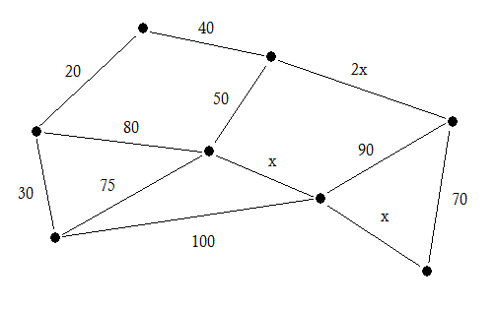

|  |
| --- |
|  |

100

Length of minimum spanning tree = 260

x =____________

2. (6 marks)  
A park has 10 large trees. The trees are denoted as vertices A to J on the following graph. Walking paths between the trees are indicated by the edges, with the numbers on the edges indicating the lengths of the paths in metres.

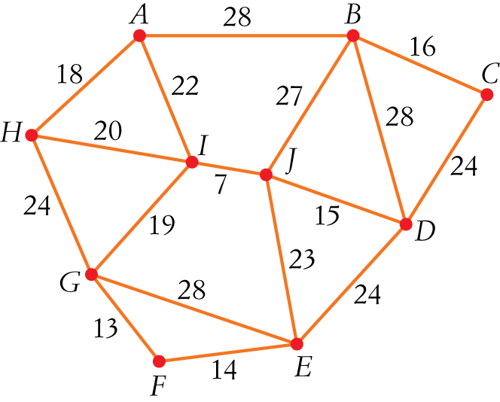

1. Determine the sum of the degrees of the vertices in this network. [2]
2. Alisha wishes to walk through the park on a route that will take her along each of the paths between the trees.  
   1. State a vertex at which Alisha should begin her walk. [1]
   2. Determine the total distance Alisha will walk. [1]
3. Alisha’s friend Alice has taken the following route: H-A-I-J-B-C-D-E-F-G-H.
   1. What is this route an example of? [1]
   2. Determine the total distance Alice will walk. [1]
      1. (8 marks)

a. Use the nodes below to draw a network for the following table which shows   
the cost (in dollars) of the telecommunications infrastructure for the   
towns A, B, C, D, E [3]

|  |  |  |  |  |  |
| --- | --- | --- | --- | --- | --- |
|  | **A** | **B** | **C** | **D** | **E** |
| **A** | - | 170 | 250 | 380 | 190 |
| **B** | 170 | - | 120 | 260 | 85 |
| **C** | 250 | 120 | - | 220 | 340 |
| **D** | 380 | 260 | 220 | - | 230 |
| **E** | 190 | 85 | 340 | 230 | - |

•••

•

•

•

•

**A**

**B**

**C**

**D**

**E**

b. Use the nodes below to show how the towns can be connected to minimise the total cost of the project (Minimum Spanning Tree). [3]

•••

•

•

•

•

**A**

**B**

**C**

**D**

**E**

c. What is the minimum cost? [2]

* + 1. (8 marks)  
       A city is to host an economic forum to be attended by the leaders of a number of nations. To ensure the safety of the leaders a sophisticated communication network, linking a number of control points, is to be set up. There are eight control points *P*1, *P*2, ..., *P*8 and the costs, in thousands of dollars, of establishing a direct link between points is given in the following table.

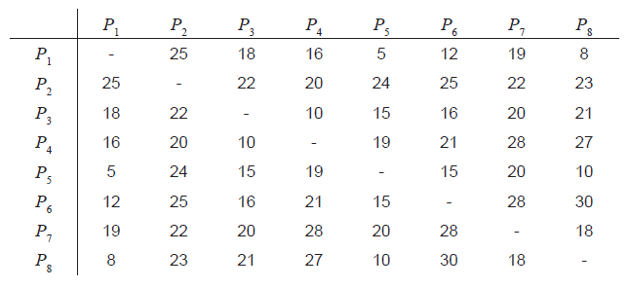

The city needs to establish a minimal cost network.

1. Use Prim’s algorithm to determine the minimal cost. [4]
2. Represent the solution found in Part (a) as a network. [2]

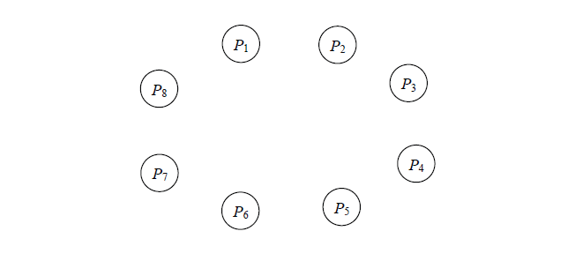

1. The planners realise that the cost of connecting the control points *P*1 and *P*2 can be reduced by $8000 by using a remote device. By how much does the use of the remote device reduce the minimum cost of constructing the network? Justify your solution. [2]

**End of Test**